Introduction to Python Programming

Team work: Corporate event

Team members:
- Basma El Khamlichi
- Mohamad Dakkouri
- Satnam Singh

- We have chosen the Tesla split corporate event, it happened on Aug. 31st, 2020.

- A stock split is when a company divides the existing shares of its stock into multiple new shares to boost the stock's liquidity. For our case, it’s a 5 for 1 split, meaning that investors will get an additional four shares for each one that they have.
This split is relevant for the firm value because even if it doesn’t change the market capitalization, it could attract more investors since shares are less expensive after a stock split .
We expect that this corporate event will have a positive impact. First, the stock becomes more accessible for retail investors and thus this may imply more volume (the institutional investors may remain more or less the same, but surely more volume will come from new retail investors, especially in the era of trading apps and the fact that trading has become more attractive among young people and it’s easier and faster nowadays to buy a stock). Moreover, Elon Musk, not like any other CEO, has a big influence and this is just an additional reason that this event will be very probably successful.

- We have downloaded the Tesla stock price data ( from 120 trading days before the event date to 5 trading days after the event date). And we’ve downloaded S&P 500 data for the same period.

- We saved the data in an excel file.

- We built our python code on Jupyter.

- We imported the excel file to Python.

- NB: We tried both extracting directly the data from Yahoo Finance and importing the data through an excel file as mentioned in 4-5-6.

- Using matplotlib, here are the evolution of the Tesla stock price over time and the volume on the same graph using the secondary axis.

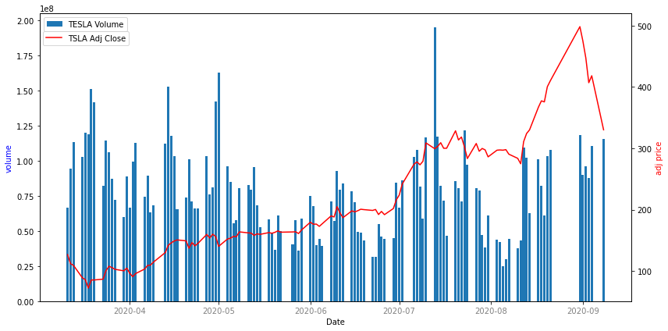

- We used pandas. DataFrame.shift to calculate the stock returns from t-120 to t+5.

- Let's define the control window as [t-120, t-6] where "t" is the event date. We Computed the average returns and the volatility over the control window using pandas.DataFrame.mean and pandas.DataFrame.std.

- Let's define the event window as [t, t+5] where "t" is the event date. We computed the average returns and the volatility over the event window like in the previous question.

- For control window, we obtained the stock’s alpha 𝛼 and beta 𝛽 by estimating the following regression (market model): 𝑅𝑐𝑤 (𝑡) = 𝛼 + 𝛽 × 𝑅𝑚,𝑐𝑤(𝑡) + 𝜖 where 𝑅𝑐𝑤 is the return of the stock on day t (control window) and 𝑅𝑚,𝑐𝑤 is the return of the S&P 500 on day t (control window): Using scipy.stats.linregress which is a linear least-squares regression we get this estimator: Y = 1.0568652899465387 X + 0.0096235'

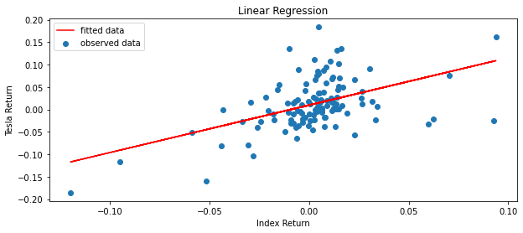

- We computed the abnormal returns of the event window by subtracting the expected returns using market model from realized returns of the event window. 𝐴𝑅,𝑒𝑤(𝑡) = 𝑅𝑒𝑤(𝑡) – ( 𝛼+ 𝛽 × 𝑅𝑚,𝑒𝑤(t) ) Where 𝑅𝑒𝑤(𝑡) is the return of the stock on day t (event window) and 𝑅𝑚,𝑒𝑤(t) is the return of the S&P 500 on day t (event window).

NB: we were curious that we don’t have the data of Monday September 7th 2020, so after some investigation we found out that in fact, New York City celebrated the first Labor Day on Sept. 5, 1882, and two years later President Grover Cleveland made the first Monday in September a national holiday. So the New York Stock Exchange and Nasdaq were both closed on Monday, Sept 7th 2020 as the labor day occurred during the weekend (Saturday sept 5th).

- We computed the cumulative abnormal returns using pandas.DataFrame.sum

- We computed the test statistics where 𝜎𝐴𝑅 is the standard deviation of the abnormal returns over the control window (not event window!).

- We compared it to the critical value (using the normal distribution, confidence level = 95%). This is how we did our inference to see if the CAR of the event window is significantly different from 0 or not :
Before doing any inference let’s remind this fundamental information:
- Alpha = 0.05 so the confidence interval is 95%
- The critical value is 1.96
- The null hypothesis :
So as the absolute value of our test statistics is > 1.96 which is the critical value for alpha = 0.05, we are 95% confident to reject the null hypothesis of . We conclude that CAR of the event window is significantly different from 0.

https://www.stocksplithistory.com/tesla/
https://www.investopedia.com/terms/s/stocksplit.asp
https://www.marketplace.org/2020/08/31/why-apple-and-tesla-are-splitting-stocks/
https://pandas.pydata.org/docs/reference/api/pandas.DataFrame.shift.html
https://pandas.pydata.org/docs/reference/api/pandas.DataFrame.mean.html?highlight=mean#pandas.DataFrame.mean
https://pandas.pydata.org/docs/reference/api/pandas.DataFrame.std.html?highlight=std#pandas.DataFrame.std
https://docs.scipy.org/doc/scipy/reference/generated/scipy.stats.linregress.html
https://pandas.pydata.org/docs/reference/api/pandas.DataFrame.sum.html

